electronics representatives association

FOR IMMEDIATE RELEASE – Nov. 3, 2017

Contact: Neda Simeonova / Communications Director / nsimeonova@era.org

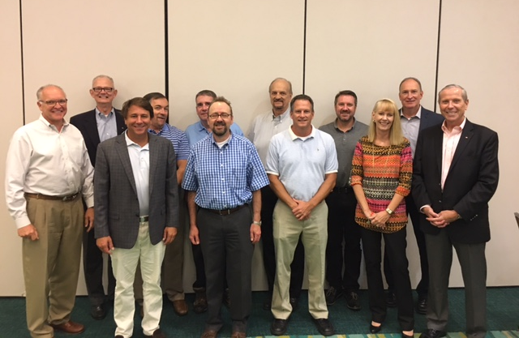
Dixie Chapter of ERA Announces New Leadership

The Dixie Chapter of the Electronics Representatives Association (ERA) announced that it has appointed new officers.

The chapter held an informative meeting in September in Huntsville, Ala., where members named Todd Ford, CPMR, of SACS as Chapter President, James Brooks, CPMR, of SACS as Vice President, Greg Gilbert of Performance Technical Sales, Inc. as VP/Secretary and Amy Bailey of Wallace Electronic Sales as VP/Treasurer.

During the meeting, attendees had the opportunity to discuss current chapter initiatives, plan upcoming member activities and help reestablish the chapter’s interest, directives and leadership.
ERA CEO Water E. Tobin attended the meeting and provided an update on key challenges faced by the electronics industry today and the value ERA National brings during these times of change.

“The Dixie Chapter was excited to have Walter Tobin present to lead the charge in renewing the chapter,” said Chapter President Todd Ford. “We had about 15 people turn out for the meeting to enjoy fellowship and rekindle our mutual interest in the Dixie ERA Chapter. If you couldn't make it this time, you missed some GREAT BBQ (Thank you, Greg!) and laughs. We are looking forward to seeing everyone at the next meeting and to an active 2018.”

According to Ford, moving forward, the chapter will focus on real and tangible issues and challenges faced by principals and customers, and the changing landscape of being a rep.

Ford was selected to attend ERA’s Chapter Officer Leadership Training (COLT) in Chicago this November. This training will be very beneficial in guiding the Dixie Chapter.

About ERA
The 82-year-old Electronics Representatives Association (ERA) is the international trade organization for professional field sales companies in the global electronics industries, manufacturers who go to market through representative firms and global distributors. It is the mission of ERA to support the professional field sales function through programs and activities that educate, inform and advocate for manufacturers’ representatives, the principals they represent and the distributors who are reps’ partners in local territories. ERA member representative firms (often called “reps”) provide field sales services on an exclusive basis to manufacturers of related (but non-competing) products in a defined territory. For more information about ERA, visit era.org.

###

Electronics Representatives Association
1325 S. Arlington Heights Road, Suite 204 • Elk Grove Village, IL 60007
phone: 312-419-1432 • fax: 312-419-1660 • email: info@era.org • URL: www.era.org

